LEARNING OBJECTIVES

This day-long program will cover the problems and issues that most locate staff encounter on a daily basis. Far from being a discussion forum, we will help locate staff recognize the contributing factors to the problems they encounter, and more importantly, learn what steps to take to solve them. A hands-on solution to real world problems, to make better locators!

SOME OF THE SUBJECTS INCLUDED ARE:
- An explanation on how the choice of locate signal/frequency or grounding techniques can create badly distorted fields that interfere with your ability to accurately map out your buried utilities.
- Revealing how and why signals “jump” or “spill” on to other buried facilities and how to first recognize it and then react to it.
- How the signals we use to locate are created, and what determines where they go, and why. Also, why don’t they go where we want them to??
- Why some of the readings we hope to use to confirm the accuracy of our locates fail in some cases, and works perfectly in others.
- Describing the process used to locate empty pipes or conduits.
- What are the steps to take to ensure and confirm an accurate locate, even in badly congested areas.
- What are the best steps to take to find broken or damaged conductors: either pipes or cables.

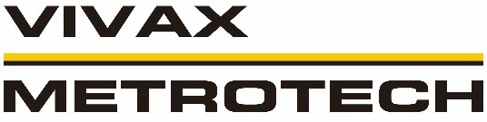

This program is led by Dave Wulff of the VIVAX-METROTECH CANADA Corporation. Dave is the most widely recognized and acclaimed utility locate trainer in Canada, and has personally provided this type of training to more than 15,000 technicians from all utility types during his 20+ years in the field.
This program does not promote any specific brand of locate gear, but promises that you’ll learn more about the way your locate gear works. He will focus on how and why they work, not on which buttons to push to turn them on. His structured approach to training is fast-paced, entertaining and meaningful; participants have told us so, year after year.

We’re so confident that you’ll benefit from this program that if you feel we did not deliver, we will give you your money back.

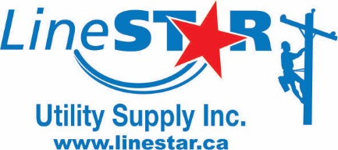

LineStar is a complete one stop shop for tools, safety equipment and apparatus to the Power, Telephone, Cable TV and Oil/Gas companies and their contractors.

Call: 306-536-5778 or email troy@linestar.ca or visit our website: www.linestar.ca for more information.
Toll Free: 1-855-766-8021

ADVANCED UNDERGROUND
CABLE AND PIPE
LOCATING SEMINAR

This program covers the full
spectrum of what locate staff needs
to know to get the job done safely,
efficiently and, most importantly, with confidence.
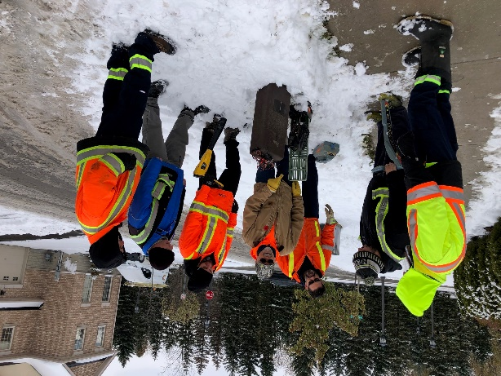

Presented by:

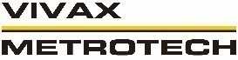
Dave Wulff Jaret Wien

REGISTRATION FORM
$175.00 + GST Per Person
Includes all course material, coffee breaks and a full lunch.
Yes! I want to register for the:

UNDERGROUND CABLE AND PIPE LOCATING SEMINAR COURSE LOCATIONS:
(Please select from the following dates)

_ Saskatoon, March 18, 2020
Holiday Inn Saskatoon Downtown, 101 Pacific Avenue
_ Regina, March 19, 2020
Holiday Inn & Suites, 1800 Prince of Whales Drive

NAME:
COMPANY:
EMAIL:
PHONE:
ADDRESS:
CITY:
POSTAL CODE:

METHOD OF PAYMENT:
_VISA _ M/C
CARD NUMBER:

CARDHOLDER NAME:

EXPIRY: CVS CODE:

SIGNATURE:

PROGRAM DATES
March 18, 2020, Saskatoon, SK
Holiday Inn Saskatoon Downtown
101 Pacific Avenue

March 19, 2020, Regina, SK
Holiday Inn & Suites Regina
1800 Prince of Whales Drive

Why should you attend?
Locating in today’s complex and congested environment has never been more difficult or necessary. This comprehensive program covers the full spectrum of what locate staff needs to know to get the job done safely, accurately and with confidence.

Join us for a day and we’ll help make you and your crews better locators, explaining and solving many of the dilemmas, mysteries and myths that locators face every day.

Our focus in on providing realistic solutions to the most common locate problems; and a lot of the more advanced ones as well. You’ll tackle the jackpots with more confidence. It’s simple – better trained techs provide better results.

No matter what locate equipment you use today, you’ll leave with a better understanding of how to make it all work best for your application.

AGENDA

8:30 - Registration and coffee service
9:00 - Greeting and Introductions
- Review of seminar materials
9:15 - Typical locate problems
9:45 - Successful Locating – the Basics
10:30 - Break
10:45 - Locating Fundamentals, continued
12:00 - Lunch (Provided)
1:00 - Advanced Applications
2:30 - Break
2:45 - Problem Solving
3:00 - Different Locate Technologies
- Fault Locating and Troubleshooting
3:45 - Questions and Answers
- Field application (weather permitting)
4:30 - Thank you and Adjourn
- Dave Wulff will be available for questions after the seminar
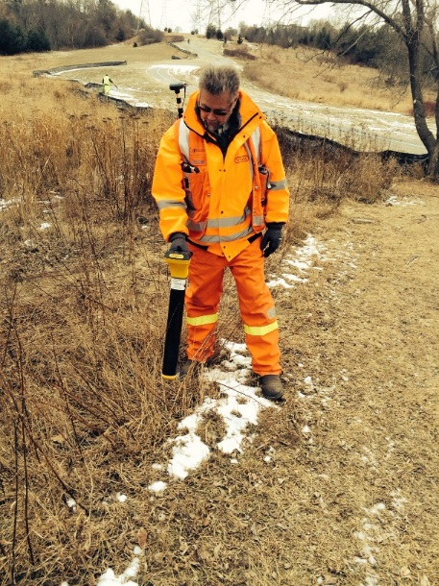

Course Instructor: Dave Wulff,

